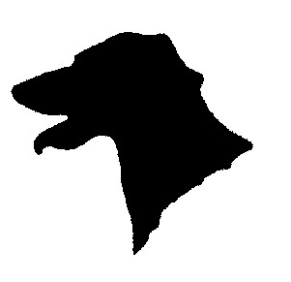
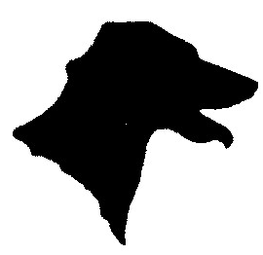
Golden Valley Dog Training Club
Kingstone, Hereford
www.goldenvalleydtc.co.uk
Where Dogs Come First

Dear Dog owner,

It is a sad part of modern times that we have to worry so much about being sued for something that may go wrong that is beyond our control.

Please read and sign the following statement to indicate your acceptance of responsibility. It is important that you are aware of the risks involved before you start the class. If you are uncomfortable signing this statement, please have a word with a Senior Instructor. It may be more appropriate to start your dog with private training if control is an issue.

LIABILITY FORM

I understand that working with animals can present risks and damages to myself and my animal.
It is my responsibility to keep my dog under control at all times during training sessions, including walking my dog to and from my car. I also agree that I alone am responsible for my dog’s behaviour in the class and on the training field / venue. To minimise all risks, I agree to disclose to the class instructor any danger or sensitivities my dog may present. I will immediately inform the instructor of any situations that may provoke aggression in my dog and I will be responsible for avoiding those situations. If I bring children to the class, I will be responsible for their care and appropriate supervision, especially around other dogs.
I understand that I am participating in this class at my own risk and by signing this waiver I assume all risks and agree to indemnify the instructor and Golden Valley Dog Training Club from any liability or damages related to my participation.

SIGNED: ______________________________________

PRINT NAME: __________________________________

DATE: __________________

